Maharashtra Industrial Development Corporation
(A Government of Maharashtra undertaking)

"Udyog Sarathi”, Marol industrial estate, Mahakali Caves Road, Andheri (East), Mumbai – 400 093.

No. MIDC/Land dept/M.V.(Land)/A89019 Date: 16/03/2021

CIRCULAR

Subject: Schemes for revival of important projects such as IT/ITES, Nano Technology, Bio-Tech, Robotics, Industries-4.0, IIT Township, Data Centre in view of Corona virus (COVID-19) global pandemic.

Reference: No. MIDC/Land dept./M.V. (Land)/D26605 dated 10/12/2020.

As per the resolution no. 6126 passed in the MIDC board of director meeting dated 16/10/2020, the policy has been issued as per the circular no. D26605 dated 10/12/2020. However there was a amendment to the Resolution No. 6138 while seconding the minutes of meeting No. 387. As per the said revised resolution, the following amendments are being done in Sr.No. 8 of MIDC Circular No. D26605 dated 10/12/2020.

If a transferred company has investment of more than Rs.2500 crores in a plot then such company should be charged handover fees of 3% instead of 10% and handover fees of 15% instead of 30% as per the FSI used in the case of informal handover of plot. The said company should submit CA certificate showing their investment in the project. If the transferred company does not invest (more than Rs.2500 crores) in the specified period then the discount given to such transferred company during the transfer should be recovered with interest. This scheme will only remain active until 31 March 2021 and there will be no extension to the said scheme under any circumstances.

There will be an investment of Rs.500 crores for the Data Centre etc. however the plot area is less than 20000 square meters. Right to grant extended development period after the handover for such plots will remain with the CEO, MIDC. Also the rights to grant benefit/approval for the schemes issued as per the above reference circulars will remain with the CEO, MIDC.

There is no other change in the reference circulars.

This circular is being issued as per the approval of Hon’ble CEO, MIDC.

- END OF DOCUMENT -

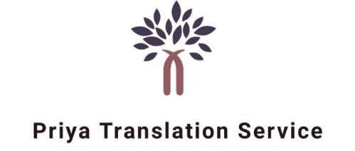
Certification of Translation Accuracy
Translation of CIRCULAR dated 16/03/2021 by Maharashtra Industrial Development Corporation from Marathi to English
We, Priya Translation Service, a professional translation services agency having no relation to the client, hereby certify that the above mentioned document has been translated by an experienced, qualified and competent professional translator, fluent in the above-mentioned language pair and that, in our best judgement, the translated text truly reflects the content, meaning and style of the original text and constitutes in every respect a complete and accurate translation of the original document.
This is to certify the correctness of the translation only. We do not guarantee that the original document, or that the statements contained in the original document are true. Further, Priya Translation Service assumes no liability for the way in which the translation is used by the customer or any third party, including end-users of the translation.
A copy of the translation is attached to this certification.

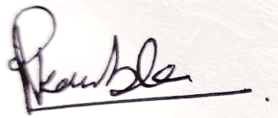
Priya Kamble, Certificate issue date: 07/03/2022
(Priya Translation Services)
Navagaon, Dahisar West,
Infant Jesus school lane,
L.M.Road, Mumbai 400 068.
Phone # +91 70457 52807
Email # priyatranslation@gmail.com

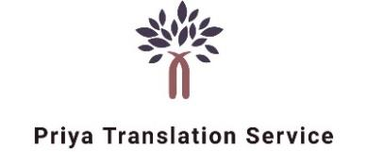

Justdial: http://www.jsdl.in/DT-432Y2QYQIUQ
Twitter: https://twitter.com/PriyaTranslati1?s=08
Website: https://www.priyatranslation.com

